Post Lab Task
Nabeera Fatima
26k-3159

Task 1:
#include<stdio.h>
int main(){
int i;
for(i=1;i<=8;i++)
{for(int j=1;j<=i;j++){
if((j==4)||(j==8))
{
printf("0");}
else printf("1"); }
printf("\n");}
return 0;
}
}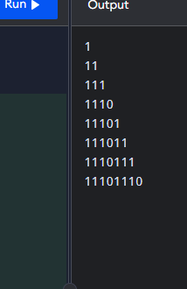

Task 2:
#include<stdio.h>
int main(){
int i;
for(i=1;i<=5;i++)
{for(int j=1;j<=i;j++){
if((j==2)||(j==4))
{
printf("0");}
else printf("1"); }
printf("\n");}
return 0;
}
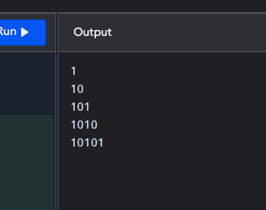

Task 3:
#include<stdio.h>
int main(){
int a[3][3],b[3][3],sum[3][3];
printf("Enter values for array\n");
for(int i=0;i<3;i++)
{for(int j=0;j<3;j++){
scanf("%d",&a[i][j]);

}}
printf("Enter Second array");
for(int i=0;i<3;i++)
{for(int j=0;j<3;j++){
scanf("%d", &b[i][j]);

}}

for(int i=0;i<3;i++)
{for(int j=0;j<3;j++){
sum[i][j]=a[i][j]+b[i][j];
}}
printf("\n Print Array A \n");
for(int i=0;i<3;i++)
{for(int j=0;j<3;j++){
printf("%d",a[i][j]);
printf("\t");
}
printf("\n");}
printf("\n Print Array B\n");
for(int i=0;i<3;i++)
{for(int j=0;j<3;j++){
printf("%d",b[i][j]);
printf("\t");
}printf("\n");}

printf("\n Sum\n");
for(int i=0;i<3;i++)
{for(int j=0;j<3;j++){
sum[i][j]=a[i][j]+b[i][j];
printf("%d %d = %d \t",a[i][j],b[i][j],sum[i][j]);
}printf("\n");}

return 0;
}

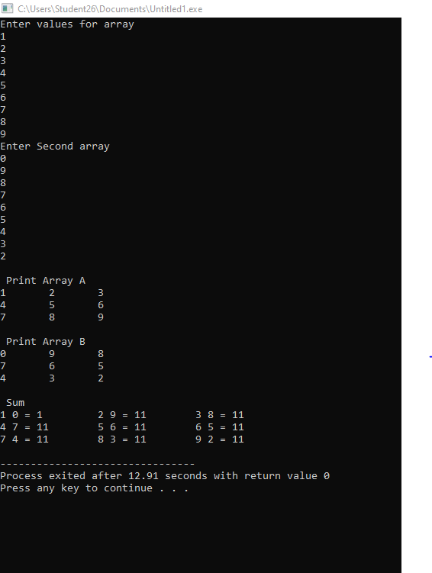

Task 4:
#include<stdio.h>
int main(){
int a[4][2],sum[4],h1,h2,h,add=0,mid=0,final=0,avg1,avg2,l1,l2,l;
printf("Enter values for array\n");
for(int i=0;i<4;i++)
{for(int j=0;j<2;j++){
scanf("%d",&a[i][j]);}}
h1=a[0][0];
h2=a[0][1];
l1=a[0][0];
l2=a[0][1];
for(int i=0;i<4;i++)
{for(int j=0;j<2;j++){
if(a[i][0]>=h1){
h1=a[i][0];
}
if(a[i][1]>=h2){
h2=a[i][1];
}
if(h1>h2){
h=h1;
}
else{

h=h2;}

if(a[i][0]<=l1){
l1=a[i][0];}
if(a[i][1]<=l2){
l2=a[i][1];
}
if(l1<l2){
l=l1;
}
else
l=l2;
}}

for(int i = 0; i < 4; i++)
{
mid = mid + a[i][0];
final = final + a[i][1];
}
avg1=mid/4;
avg2=final/4;

for(int i=0;i<4;i++)
{
sum[i]=a[i][0]+a[i][1];
}

printf("\n Print Array \n");
for(int i=0;i<4;i++)
{for(int j=0;j<2;j++){
printf("%d",a[i][j]);
printf("\t");}
printf("= %d ",sum[i]);
printf("\n");
}
printf("\nHighestMid marks = %d",h1);
printf("\nHighestFinal marks = %d",h2);
printf("\nLowest Mid marks = %d",l1);
printf("\nLowest finalmarks = %d",l2);
printf("\nHighest marks = %d",h);
printf("\nLowest marks = %d",l);
printf("\nAverage Mid marks = %d", avg1);
printf("\nAverage Final marks = %d", avg2);

return 0;

}

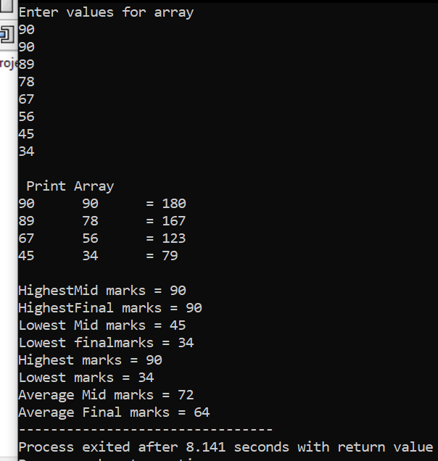

Task 5:
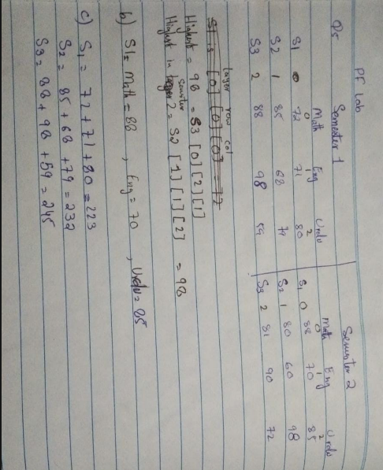
Task 6:
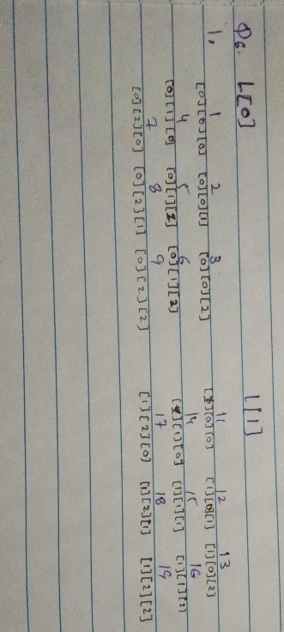
Task 7:
#include <stdio.h>
int main()
{
int salary[3][4][3];
int total, deptTotal, high;
int highD, highE, highM;

for(int d = 0; d < 3; d++)
{
for(int e = 0; e < 4; e++)
{
for(int m = 0; m < 3; m++)
{

scanf("%d", &salary[d][e][m]);
}
}
}

high = salary[0][0][0];
highD = 0;
highE = 0;
highM = 0;

// Find highest salary
for(int d = 0; d < 3; d++)
{
for(int e = 0; e < 4; e++)
{
for(int m = 0; m < 3; m++)
{
if(salary[d][e][m] > high)
{
high = salary[d][e][m];
highD = d;
highE = e;
highM = m;
}
}
}
}

for(int d = 0; d < 3; d++)
{
for(int e = 0; e < 4; e++)
{
total = 0;

for(int m = 0; m < 3; m++)
{
total = total + salary[d][e][m];
}

printf("\nDepartment %d, Employee %d total = %d",
d+1, e+1, total);
}
}

for(int d = 0; d < 3; d++)
{
deptTotal = 0;

for(int e = 0; e < 4; e++)
{
for(int m = 0; m < 3; m++)
{
deptTotal = deptTotal + salary[d][e][m];
}
}

printf("\n\nDepartment %d total salary = %d", d+1, deptTotal);
printf("\nDepartment %d average monthly salary = %.2f", d+1, deptTotal / 3.0);
}

printf("\n\nHighest salary = %d", high);
printf("\nDepartment = %d", highD+1);
printf("\nEmployee = %d", highE+1);
printf("\nMonth = %d", highM+1);

return 0;
}
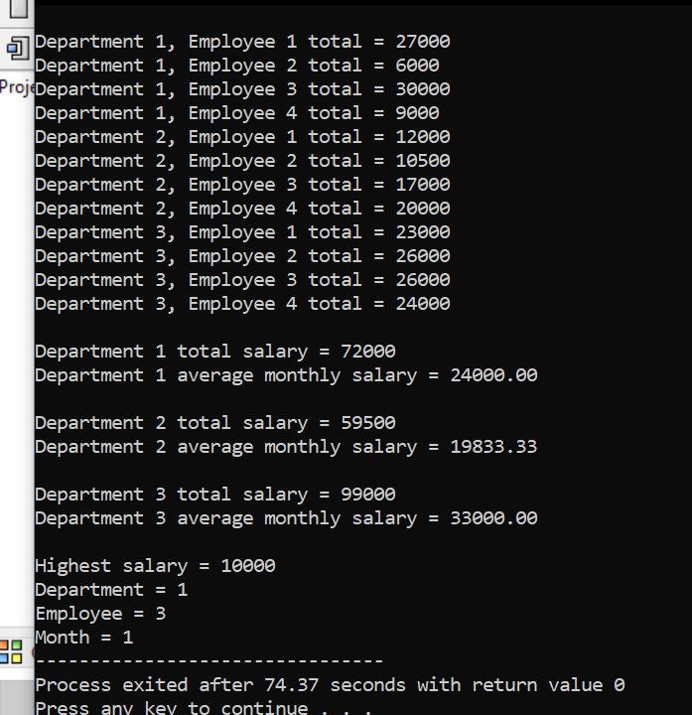
Task 8:
#include <stdio.h>
int main()
{
int marks[2][5][4];
int total, sectionTotal, high;
int highStudent;

for(int s = 0; s < 2; s++)
{
for(int st = 0; st < 5; st++)
{
for(int a = 0; a < 4; a++)
{
printf("Enter marks for Section %d, Student %d, Assignment %d: ",
s+1, st+1, a+1);
scanf("%d", &marks[s][st][a]);
}
}
}

for(int s = 0; s < 2; s++)
{
high = -1;
highStudent = 0;

for(int st = 0; st < 5; st++)
{
total = 0;

for(int a = 0; a < 4; a++)
{
total = total + marks[s][st][a];
}

printf("\nSection %d, Student %d total = %d",
s+1, st+1, total);

if(total < 20)
{
printf(" - Total is below 20");
}

if(total > high)
{
high = total;
highStudent = st;
}
}

printf("\nHighest total in Section %d = %d", s+1, high);
printf("\nStudent = %d\n", highStudent+1);
}

for(int s = 0; s < 2; s++)
{
sectionTotal = 0;

printf("\nSection %d assignment averages:\n", s+1);

for(int a = 0; a < 4; a++)
{
total = 0;

for(int st = 0; st < 5; st++)
{
total = total + marks[s][st][a];
}

printf("Assignment %d average = %.2f\n",
a+1, total / 5.0);
}

for(int st = 0; st < 5; st++)
{
for(int a = 0; a < 4; a++)
{
sectionTotal = sectionTotal + marks[s][st][a];
}
}

printf("Section %d total marks = %d\n", s+1, sectionTotal);
}

return 0;
}
